# DIS-US-IL-Mississippian-Gorget

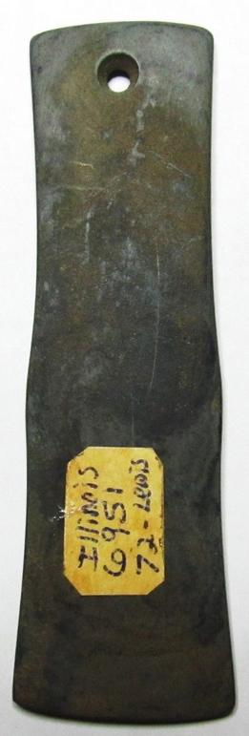 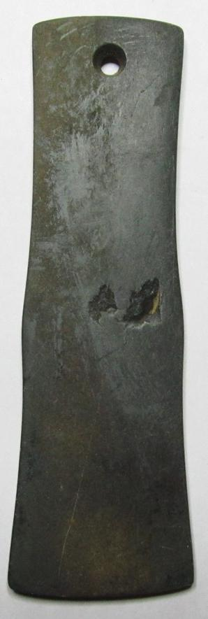

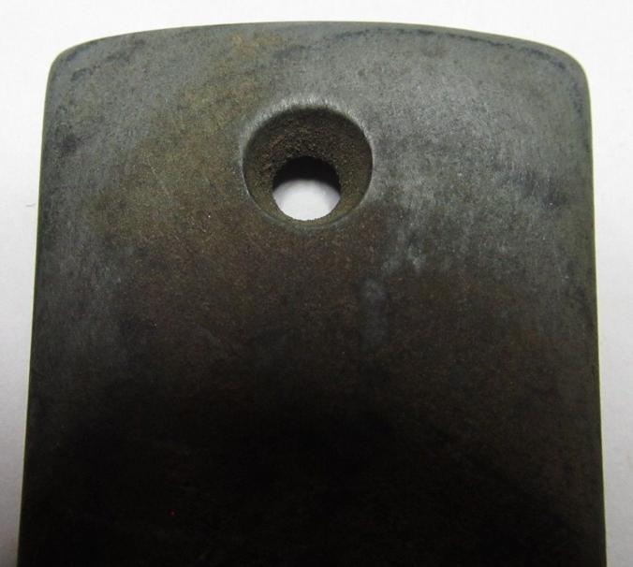

old by [2010katieskollec...](http://myworld.ebay.com/2010katieskollectables2010) ( [829](http://feedback.ebay.com/ws/eBayISAPI.dll?ViewFeedback&userid=2010katieskollectables2010) )

### Delivery package 1 of 1

Estimated delivery Monday, Jan 25, 2016 - Tuesday, Feb 2, 2016

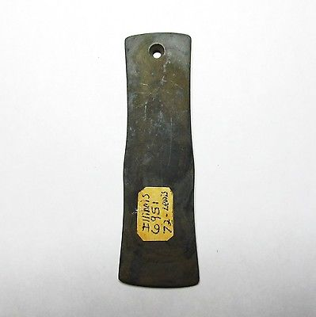

#### [Pre-Columbian Native Mound Builder Stone Pendant ~ From an old collection!](http://www.ebay.com/itm/272101336658)

|  |  |
| --- | --- |
| Item price | $76.00 |
| Quantity | 1 |
| Item number | 272101336658 |
| Shipping service | Standard Shipping from outside US |